Employee Performance & Retention Analysis

1. Introduction
The objective of this project is to analyse employee performance and retention patterns using Python for data cleaning and exploratory data analysis, data pre-processing, key metrics analysis, and etc.., and Power BI for business insights visualization.
The study focuses on understanding how factors such as age, education, training, department, and performance indicators influence employee performance and retention.
The final output includes an interactive HR dashboard and actionable recommendations for improving workforce productivity.
2. Problem Statement
The objective of the project is to analyse HR data to assess employee performance, identify trends influencing retention, and provide recommendations for improving employee productivity and reducing turnover. Specifically, the project aims to:
● Identify performance patterns based on factors such as age, education, department, training.
● Examine retention trends based on employee characteristics such as tenure, performance rating, and awards.
● Provide recommendations for improving employee engagement and retention strategies by analysing the relationship between key employee metrics.
3. Dataset Information
The dataset includes records of employees with various demographics, performance, and organizational details. Key variables in the dataset are:
● employee_id: Unique identifier for each employee
● department: The department the works in
● region: Geographical region of the employee
● education: The education level of the employee
● gender: Gender of the employee
● recruitment_channel: The method by which the employee was recruited
● no_of_trainings: Number of training sessions attended by the employee
● age: Age of the employee
● previous_year_rating: Rating of the employee’s performance from the previous year
● length_of_service: How long the employee has worked in the company
● KPIs_met_more_than_80: Whether the employee met more than 80% of their KPIs
● awards_won: Number of awards the employee has won
● avg_training_score: Average score of the employee in training programs
The dataset was cleaned and processed using Python to ensure consistency and accuracy before dashboard creation.
Tools:
●Python [data analysis, pre-processing, using libraries- pandas, matplotlib, seaborn, and scikit-learn]
●Jupyter Notebook
●Visualization Tools[matplotlib]
●Statistical Analysis [correlations, averages]
●Power BI [ Interactive Dashboard]
●MS Word

4. Methodology
Python (Jupyter Notebook)
The following steps were performed:
● Loaded and inspected the dataset
● Checked for missing values and inconsistencies
● Filled missing numerical and categorical values
● Encoded categorical variables
● Standardized text formats

1.Performed Exploratory Data Analysis (EDA):
● Descriptive Statistics
● Check for Missing Value
● Numeric Distribution
● Categorical Columns
● Correlation Matrix
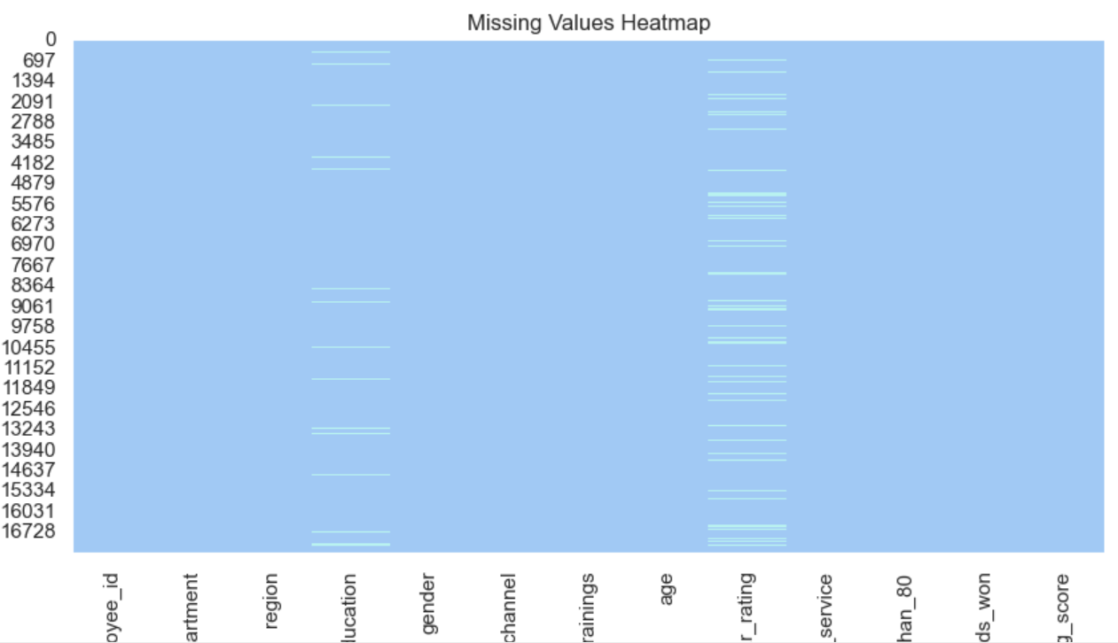

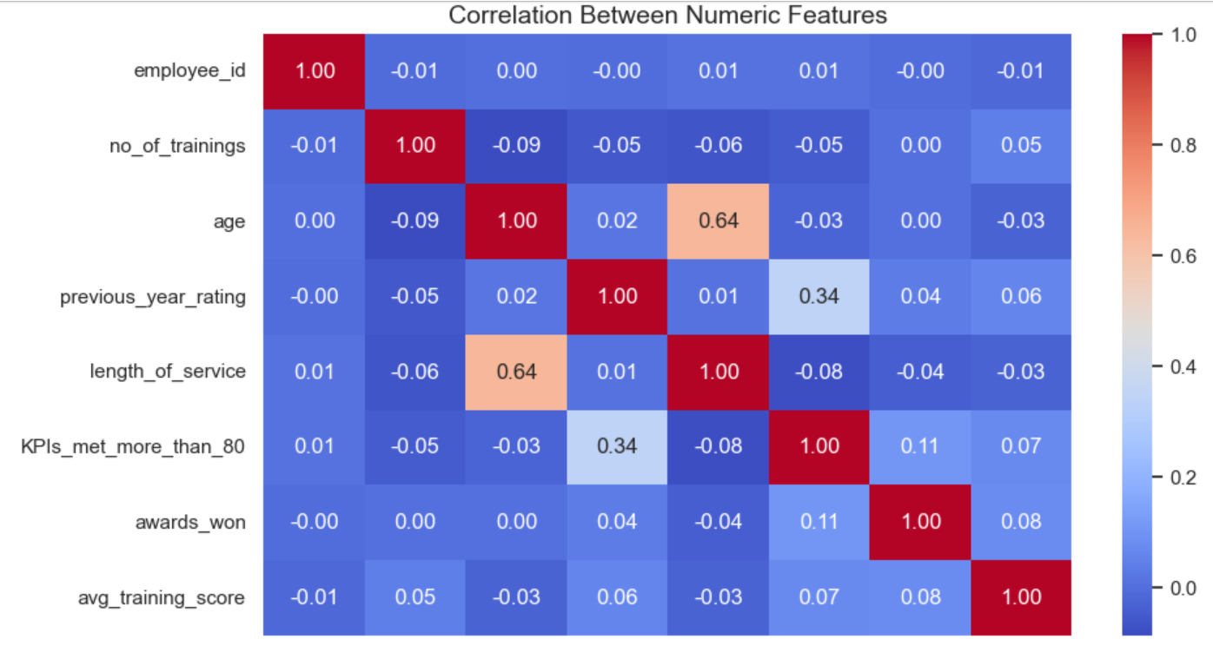

Exploratory Data Analysis (EDA) was conducted to identify key patterns and insights about employee demographics, performance, and retention. The analysis used Python, Pandas, Seaborn, and Matplotlib for visualization
.
2. Data Pre-Processing
● Handle Missing Values
● Encode Categorical Variables
● Check Data Consistency & Data Types
● Check for Duplicated Outliers

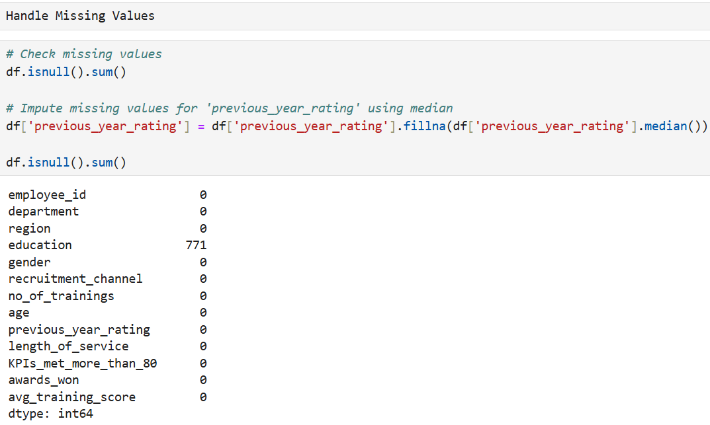

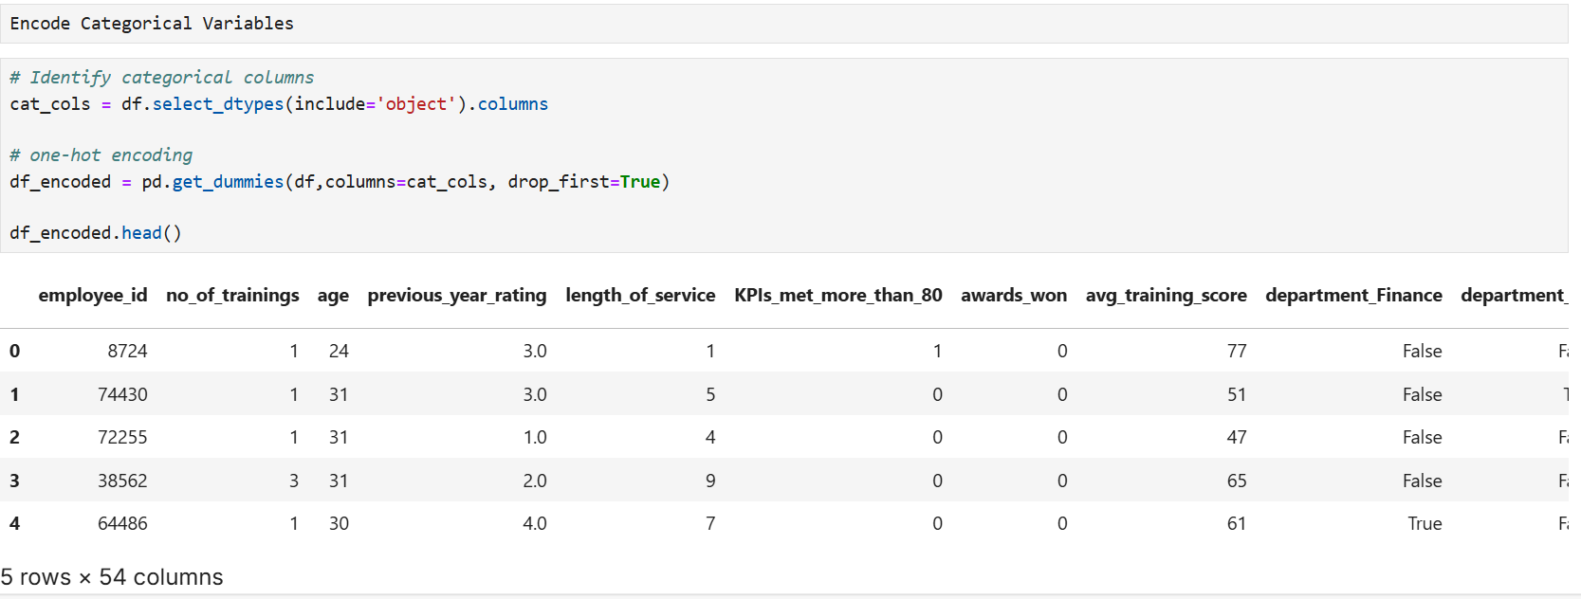
The pre-processing ensured that the dataset is clean and free of missing or duplicate values, properly encoded for machine learning or statistical analysis, consistent in formatting and ready for visualization and predictive modelling.
3.Key Metrics Analysis
● Length of Service
● Average Training Score
● Previous Year Training
● Awards won
● KPIs Met More Than 80%

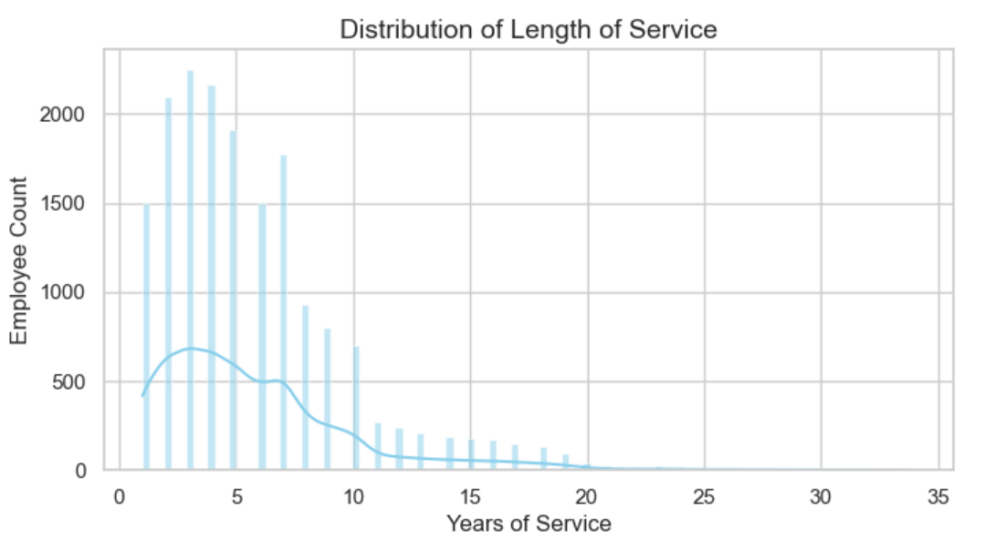

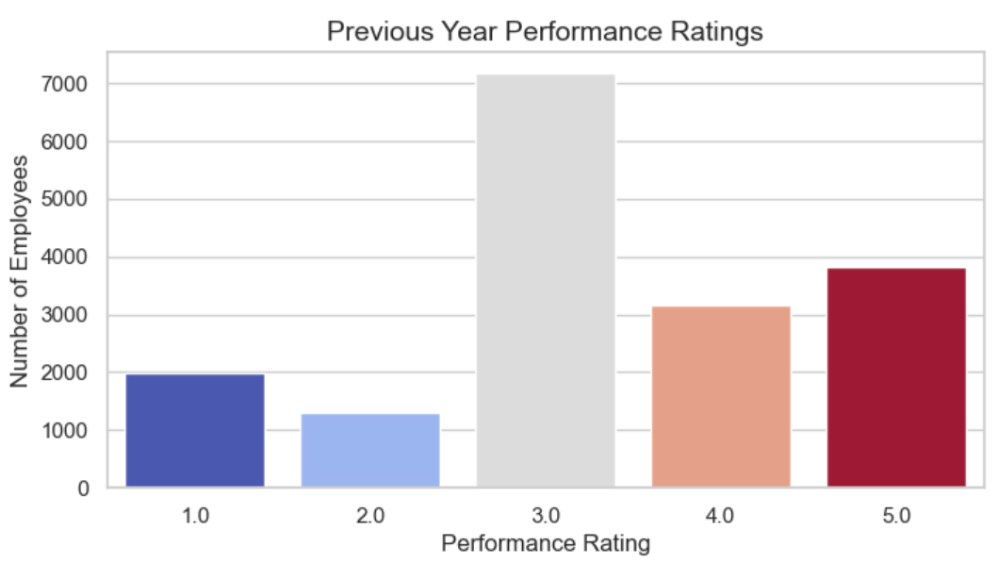

The Key Metrics Analysis provides valuable insights into employee performance, engagement, and retention trends within the organization. The analysis highlights that employee show steady participation and consistent performance, but recognition, high KPI achievement, and long-term retention remain areas for improvement.

4.Retention Trends Analysis
● Retention Trend by Age
● Retention Trend by Education
● Retention Trend by Department
● Retention Trend by Training

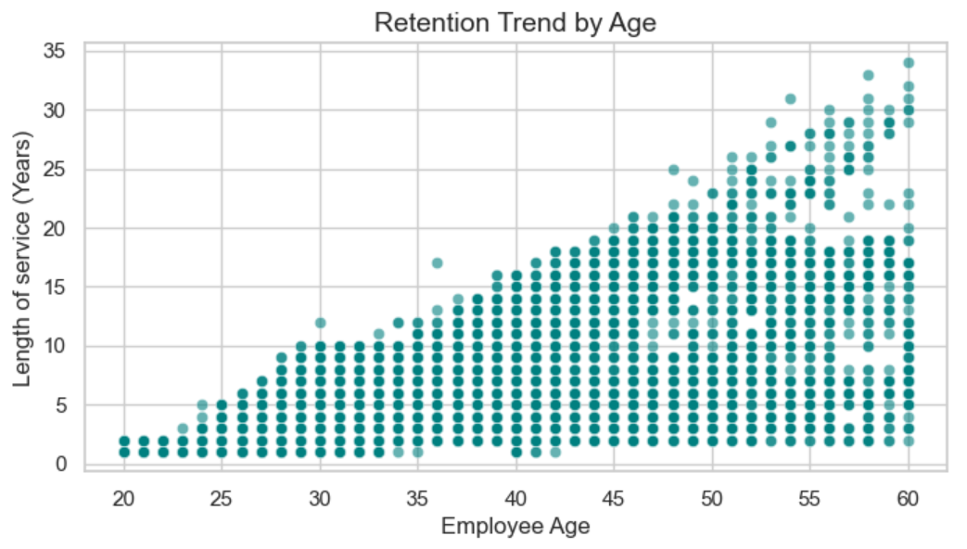

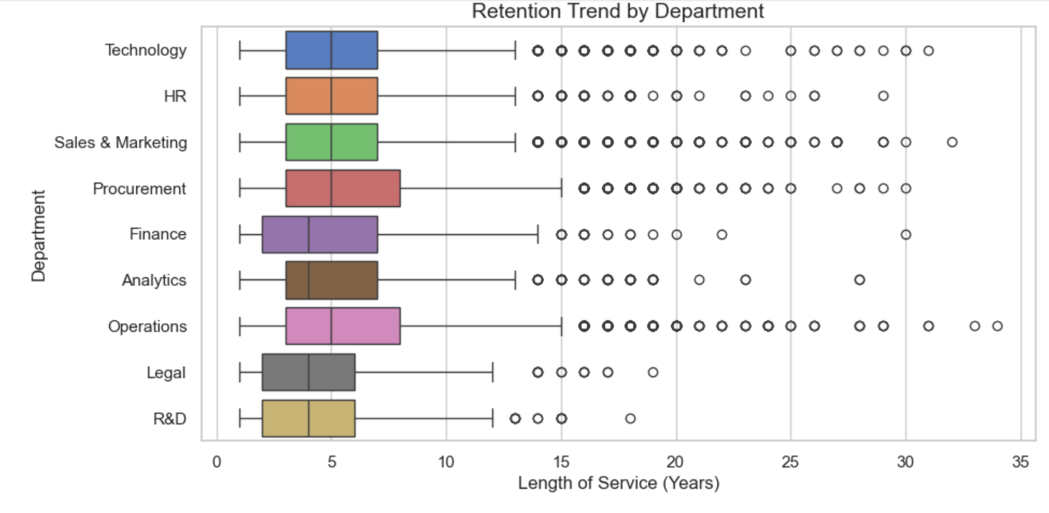
Employees in HR, Technology, and Sales & Marketing departments show higher median retention, indicating longer service periods. Meanwhile, departments like R&D and Legal have shorter tenure ranges, suggesting higher turnover or more project-based roles. Overall, retention varies slightly across departments, with core business and tech teams showing better stability.

Power BI Dashboard
1.KPI Cards
● Total Employees
● KPI%
● Avg Training Score
● Awards Won

2.Performance & Department Charts
● Employee Count by Department
● Avg Training Score by Department
● Avg Length Service by Department

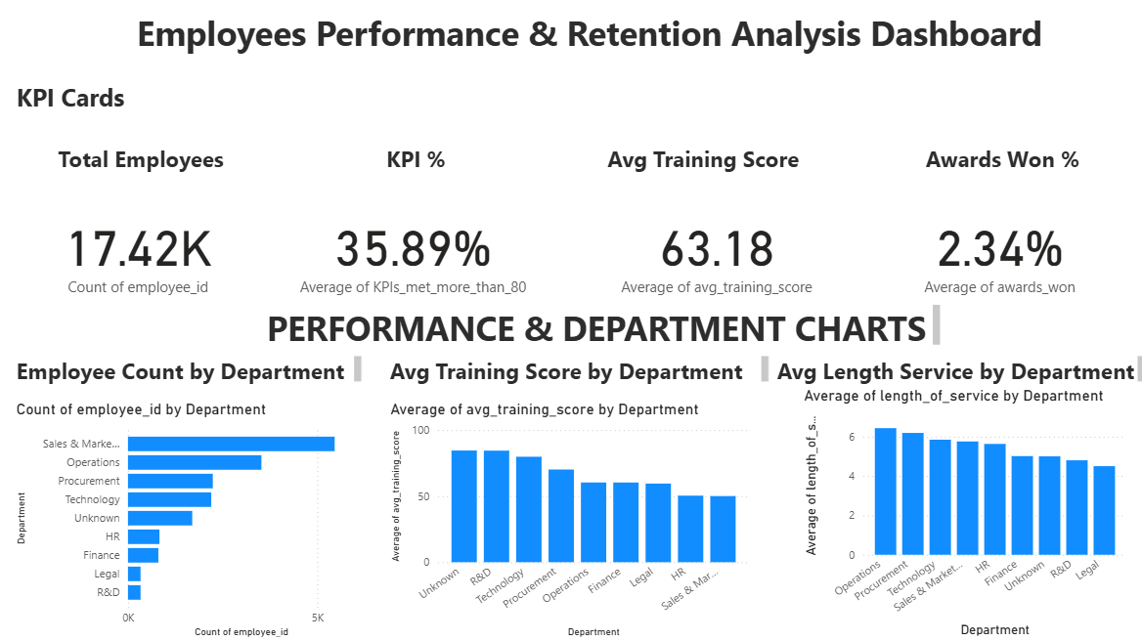

3.Retention Trends Analysis
● KPI Performance by Training Count
● Age vs Length of Service
● Education Level Distribution of Employees
● Gender Distribution of Employees
● Employee Count by Recruitment Channel
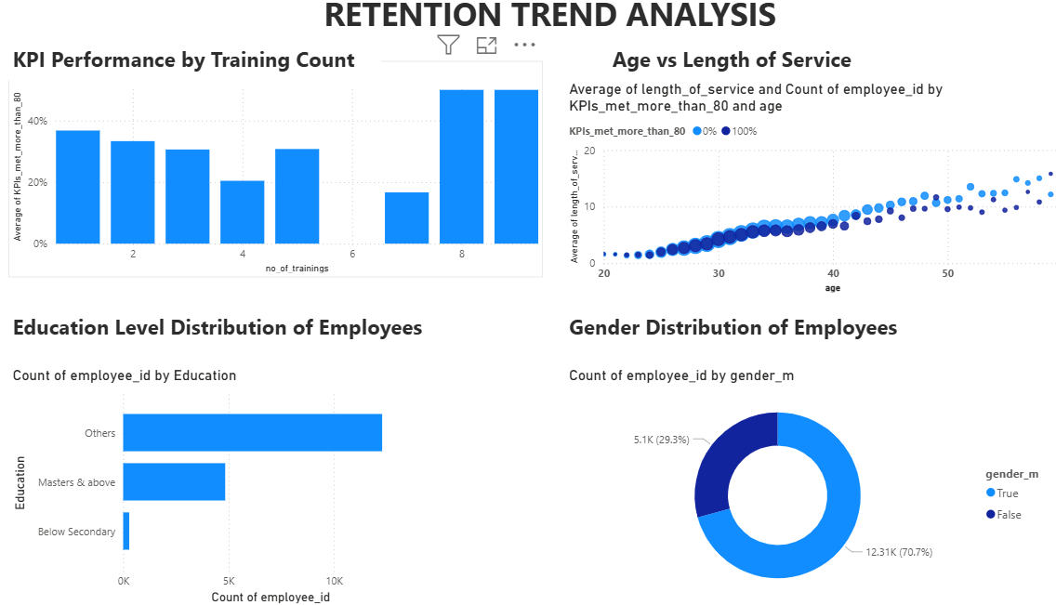
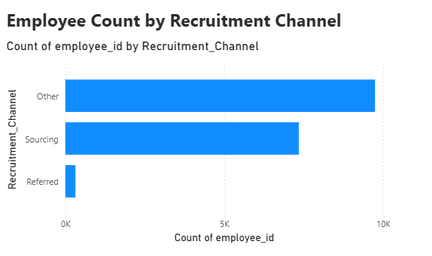

3.Slicers
●Education
●Department
●Recruitment_Channel
●No_of_Training
●Age

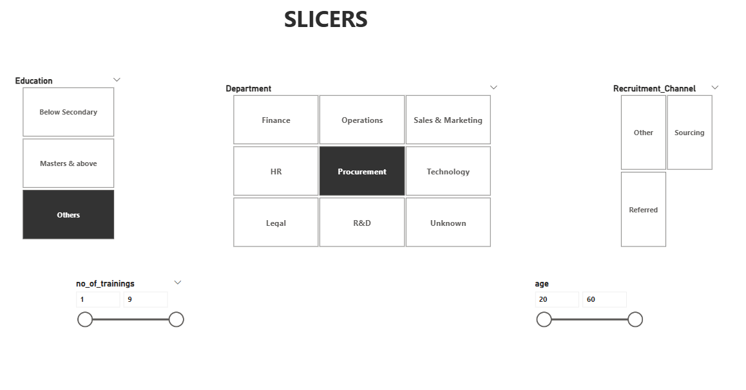
Business Storytelling:
Organizations often struggle with declining employee performance and unexpected attrition, which directly impacts productivity, project continuity, and recruitment costs. Leadership needs more than raw numbers—they need clarity on why employees leave, who is at risk, and where performance is breaking down.
In this project, I approached workforce data as a business problem, not as a dataset.
I began by analyzing employee performance, tenure, training history, KPIs, and engagement levels to understand patterns behind employee success and retention. After cleaning and preparing the dataset using Python and Excel, I conducted detailed Exploratory Data Analysis to uncover trends, performance gaps, and risk indicators.
Using Power BI, I developed an interactive dashboard to visualize retention metrics, performance distribution, and key workforce drivers across teams and experience levels. The dashboard enabled quick identification of high-risk employee segments and highlighted performance indicators linked to attrition.
From the analysis, it became evident that:
Employees with low training exposure and performance ratings showed higher attrition risk
Longer-serving employees exhibited stronger performance stability
Teams with high overtime and lower KPI scores faced increased retention challenges
Based on these insights, I provided actionable recommendations, including targeted training programs, performance improvement plans, and employee engagement strategies to minimize attrition and improve productivity.
This project demonstrates my ability to transform workforce data into actionable insights and business decisions that improve organizational performance and employee retention.
Key Insights & Recommendations
Workforce Overview
○Total employees:17.4k
○Workforce is male-dominated (~67%)
○Majority are mid-level education, very few below secondary.
●Performance Insights
○Only 35.89% meet KPI>-low overall performance.
○Average training score is 63, meaning training quality needs improvement.
○Only 2.34% employees receive awards-very low recognition.
●Department Analysis
○Sales & Marketing = largest department but very low retention.
○Technology & Operations = highest training score + stable retention.
○Procurement & R&D = good training scores but smaller teams.
Retention Trend Analysis
●Younger employees leave early-early attrition problem.
○Older employees stay longer (highly length of service).
○Employees with 1-3 trainings or higher perform better.
●Education level impacts retention-Masters and Above stay longest.
○Most hires come through other channels, not employee referrals.
○Referrals are low-potential improvement for hiring quality.
Recommendations
●Improve KPI Performance
○Provide structured quarterly performance plans.
○Introduce more skill-based training for low-performing teams.
●Strengthen Recognition Programs
○Increase award frequently beyond 2.34%
○Introduce monthly recognition badges.
●Reduce Early Attrition
○Offer onboarding mentorship for young employees.
○Build clear career path programs.
●Improving Training Quality
○Redesign training modules for Sales, Marketing, and Operations.
○Track training effectiveness per employee.
●Optimize Hiring Channel Mix
○Increase referral bonuses.
○Reduce dependency on "Other" channels to lower cost.

Conclusion:
This project successfully analysed employee performance and retention patterns using python and power BI. Through detailed data processing, Exploratory Data Analysis (EDA), Data Pre-processing, Key Metrics Analysis, Retention Trends Analysis, Predictive Insights, and Interactive dashboard visualizations. Several key insights were identified-including low KPI achievement rates, limited recognition programs, uneven training quality, and early attrition among younger employees. The findings enabled data-driven recommendations to improve workforce performance, Optimize- training, strengthen recognition, and enhance retention strategies. Overall, this project demonstrates strong capabilities in HR analytics, business problem-solving, and end to end analytical reporting.

